# Week 5 Submission Group: 19

Word limit=1000. Use bullet points and be concise. Cite reference

# Project Update: 1 point

1. What is the purpose and task in this step?

Evaluate our design both based on the prototyping and testing we did in the previous week, and from the final design that is currently being made. Based on this evaluation, we need to make changes to our design to optimise for strength, ease of movement, ease of assembly, and generally just try to make our final design congruent with our problem definition and constraints from step one.

1. What did you achieve in this step? Highlight your evaluation and optimization results.

We manufactured the central structural bracket using a 3d printer, laser cut our base platform and 3D printed all our plastic parts.

Initially this bracket was wider and thinner, but a wider bracket also meant that the heavy z axis was further away from the aluminium rail. This caused unwanted bending. Consequently the bracket was redesigned thicker and with extra supports for stability. All parts with misaligned dimensions were properly aligned.

We tried to use sheet metal for extra strength, but the manufacturing process was not accurate enough and manufacturing was taking too long.

An acrylic platform was laser cut to align the motor and spinning platform with the z axis. Initially this design used sheet metal and the components were fastened with screws. We decided to use acrylic because most of the support comes from the sides – not the base. The extra assembly time for screwing in the motor and turntable aligning brackets was reduced by making them fit into slots.

Originally the alignment brackets for the turntable and base motor were screw in. However, this would have made the assembly process significantly more time consuming and difficult, so the design was changed so that these brackets slipped into the base. One of these brackets (the one for the turntable) did not provide enough support to prevent the turntable from tipping over. This bracket was subsequently redesigned to support the outer edges of the turntable. The driving gear was too thick and was reduced by 1mm.

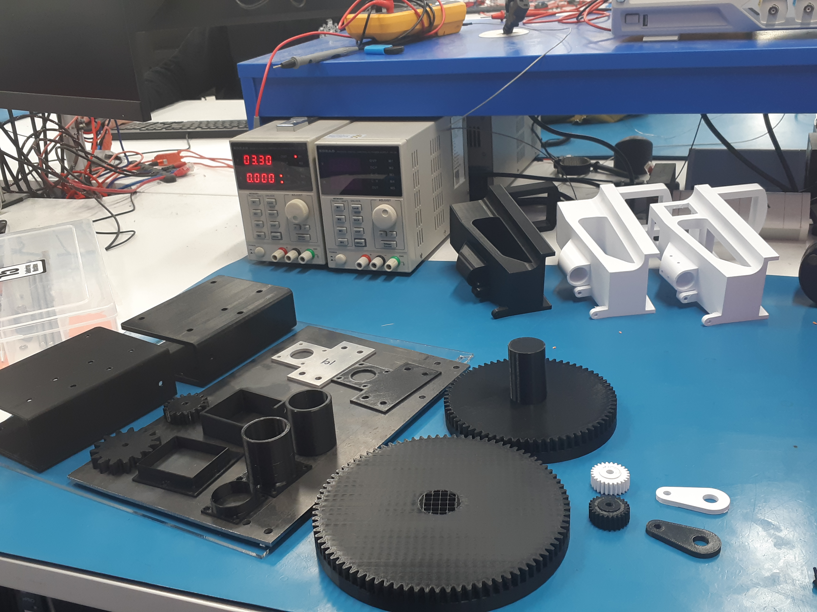

**Figure 1. All of the 3D printed and sheet metal prototypes and final products**

Figure 1 shows some of the changes made to various parts half way through the week. Some parts were redesigned further after this photo was taken. Our turntable (the large toothed round part) was made smaller to improve manufacturing time and quality, and to fit the machine better. The turntable mounting bracket’s height was increased to provide more support, and the screw holes were removed. The bracket that holds the solder feeding component (in the top left of the image) was redesigned such that the soldering iron could be aligned using set screws or grub screws. Dimensioning issues also necessitated the reprinting of some components such as the feeder gear and cover (bottom right).

# Homework: 1 point

1. Show answers with explanation/procedures for Homework Questions given in this week lectures.

Set 1

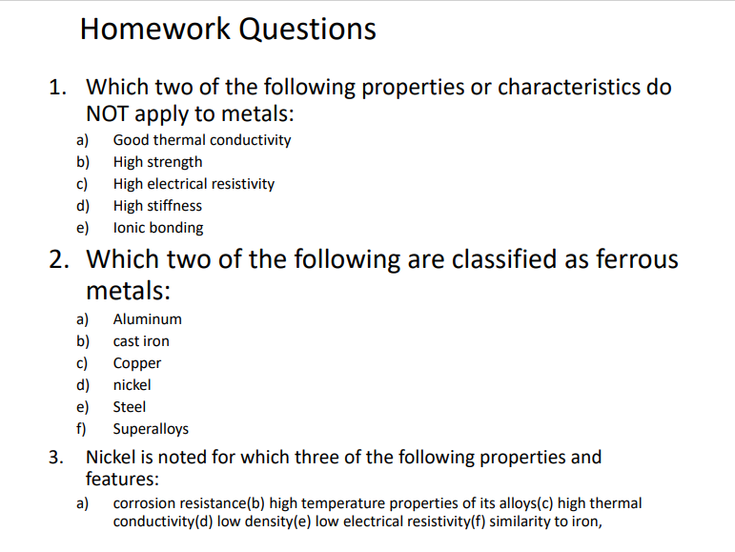

1. High electrical resistivity and ionic bonding – Metals are bonded by metallic bonding, which comprises a “sea of electrons” and the metal cations. The free electrons give metals high electrical conductivity (and lower electrical resistivity).

2. Cast Iron and steel are the only metals from the list that contain iron (Fe).

3. Corrosion resistance, high thermal conductivity and low electrical resistivity

Set 2

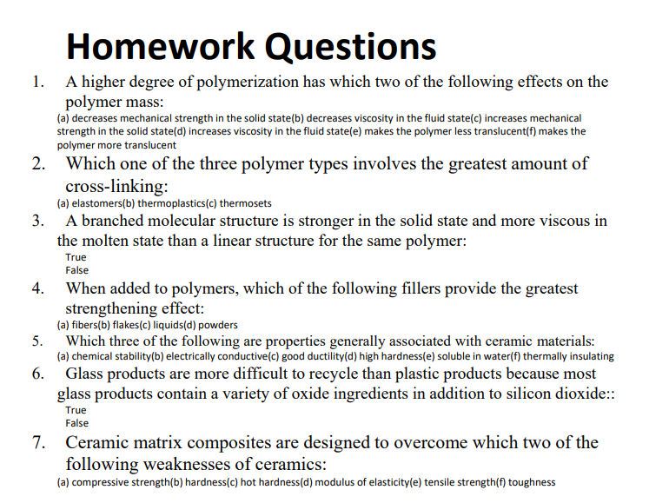

1. (c)Increases mechanical strength in the solid state and (d)increases viscosity in the fluid state This is because as the degree of polymerisation increases, the polymer chain becomes tangled up, which increases the van der waals forces and the polymer requires more energy or force to stretch or deform.

2. (c)Thermoset – cross linked polymer chains materials require high amounts of heat energy to deform (break / stretch the covalent bonds).

3. True because there are more van der waals forces

4. (a)Fibres

5. (a)chemical stability, (d)high hardness, (f)thermally insulating

6. False

7. (f)toughness and (e)tensile strength

# Weekly Individual Contributions

|  |  |  |  |
| --- | --- | --- | --- |
| Name | Contributions | Mark | Signature |
| Reuben Smitheram | Helped answer homework questions. Evaluated, redesigned and manufactured various components, tested the machines operation using G code. Documented changes to parts and discussed developments with the group. | 2 | Reuben |
| Jack Edwards | Helped answer homework questions and made some parts | 2 | Jack |
| John-Luke Fenn | Helped assemble the CNC machine for testing, discuss optimisation ideas and manufacture the acrylic base. | 2 | John-Luke Fenn |
| Lucas Kwan | Evaluated prototype, redesigned and manufactured parts. Assembled and tested CNC machine with G code. | 2 | Lucas |
|  |  | Sum=2*N |  |

N: number of group members. Every group member is expected to take part in the whole process, not just work on one part, for example, report writing only.

# References

ENMT 221 Lecture 11

<https://learn.canterbury.ac.nz/pluginfile.php/6571170/mod_resource/content/4/Lecture%2011%20engineering%20materilals%20polymer%20ceramics.pdf>

ENMT 221 Lecture 10

<https://learn.canterbury.ac.nz/pluginfile.php/6571168/mod_resource/content/4/Lecture%2010%20Engineering%20materilals%20metals.pdf>

ENMT 221 Lecture 12

<https://learn.canterbury.ac.nz/pluginfile.php/6571169/mod_resource/content/5/Lecture%2012%20Machining.pdf>